Steps involved in Project:

1. Understand the Problem statement and collect required data.

* Assuming you have data and problem statement.
* Here we will use a text classification problem.

1. Create a github repo :
   1. Login to github account
   2. Create a new repo
      1. Go to new repository – give a project name—add readme file—select gitignore (python)
      2. Copy the https clone link

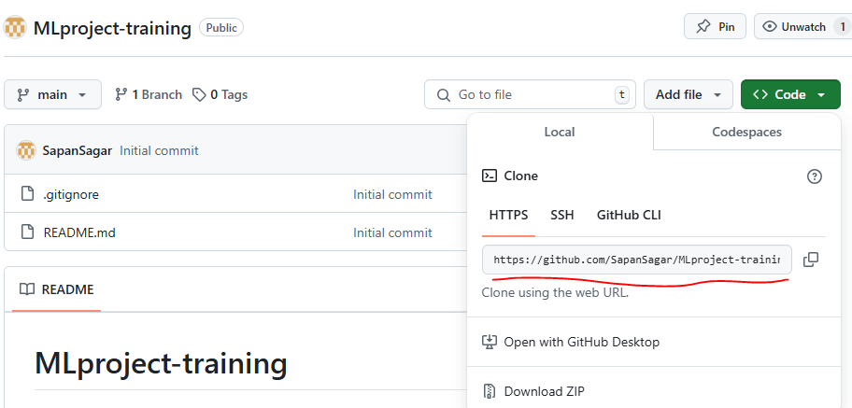

* 1. Go to your laptop/system and clone the same repo
     1. Open cmd prompt and select the path where you want to clone the repo
     2. Use command: git clone (copied clone link from previous step).
     3. You will have same folder from github to your system. Go to the folder and open vs code in same path.

1. Create virtual environment at your system
   * 1. python -m venv myenv (myenv is the name of env. And can be changed)
     2. to activate the env. Use : myenv\Scripts\activate
2. Will start with experiment of project and create experiment jupyter file. Later we can convert the same in moduler codes.
   1. Refer experiment_initial.ipynb file for details.
   2. We have created a binary classifier model following data ingestion,preprocessing,feature extraction,model building and evaluation in jupyter notebook.
3. Now we will convert the jupyter code in moduler code
   1. Follow the folder –mlpipeline-dvc-demo .